Kanokphan Sirithienthong 6610750092

Part A:
Step 1: Load and Inspect the Data
The dataset flower.txt is loaded into R as a data frame using read.table(), ensuring headers are recognized and tab-separated values are correctly imported. The str() function is used to inspect the structure of the dataset, displaying variable names, data types, and an overview of the values.

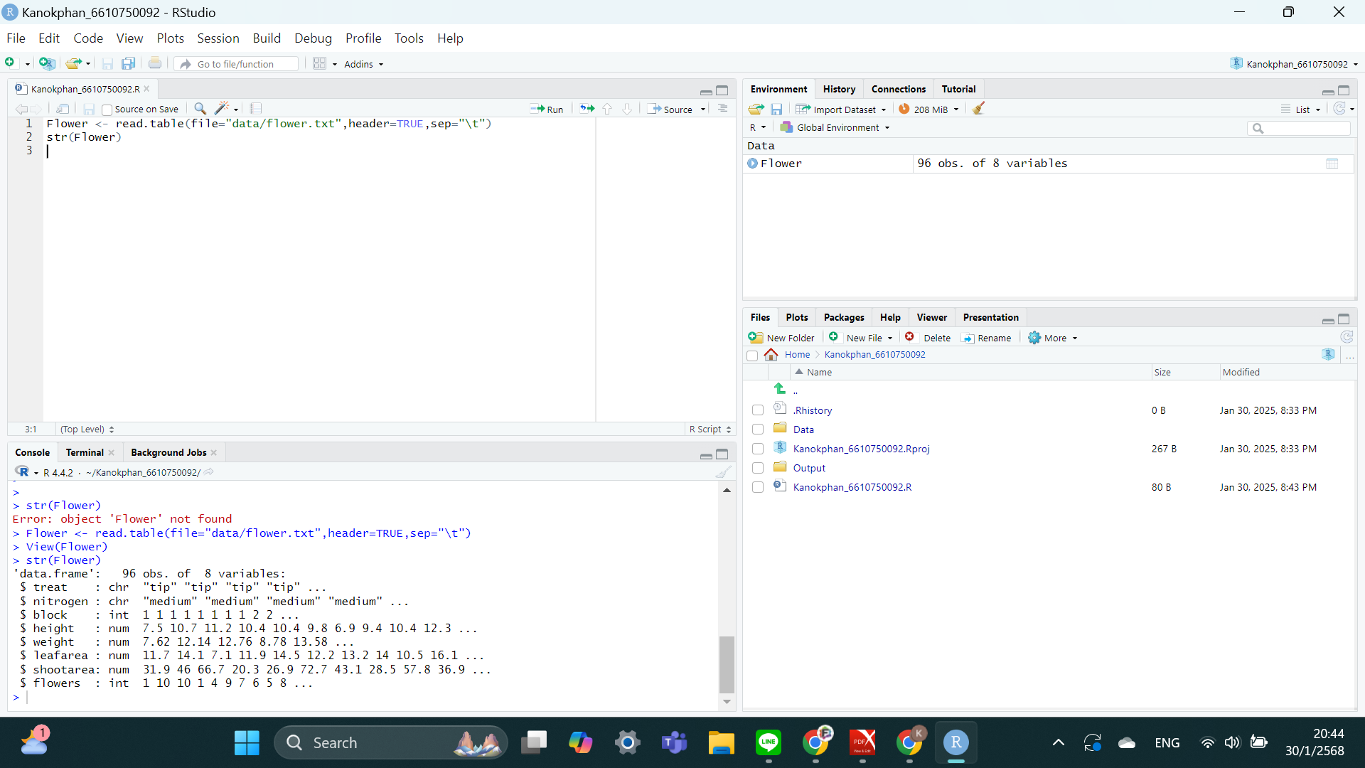

Step 2: Order Data by Weight
The dataset is sorted in descending order based on the weight variable using the order() function. This rearranges the observations so that the heaviest weights appear first, facilitating further analysis based on weight ranking.
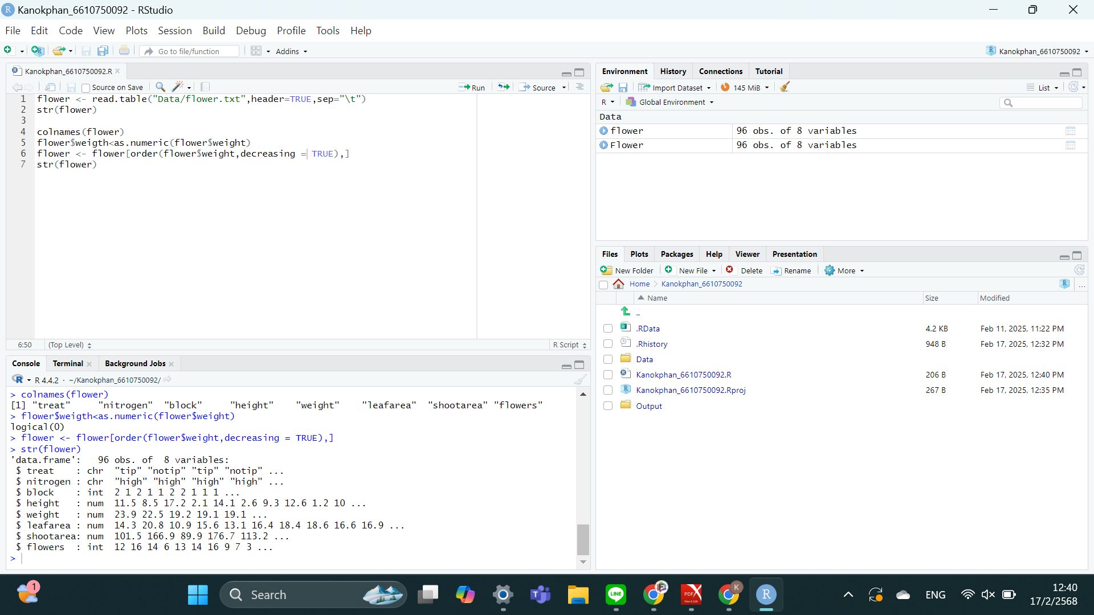

Step 3: Extract the 45th Observation
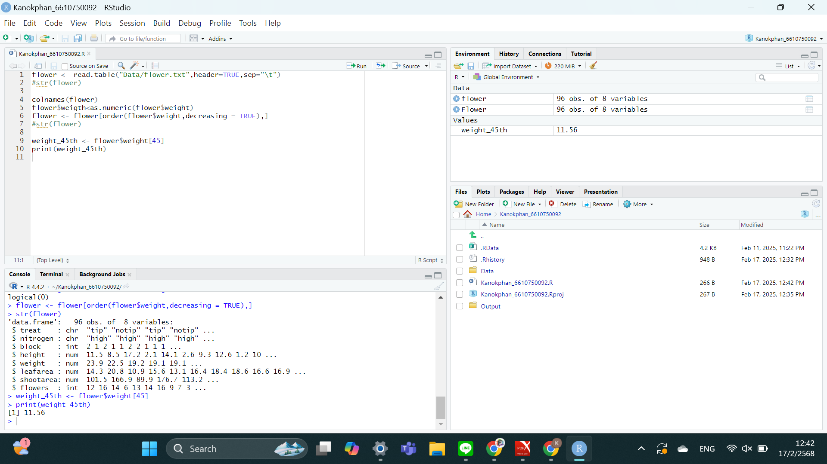
The 45th observation’s weight value is extracted and stored in weight_45th. The print() function is used to display this value, which helps in identifying specific observations based on rank.

Step 4: Extract the First 20 Rows for Specific Variables
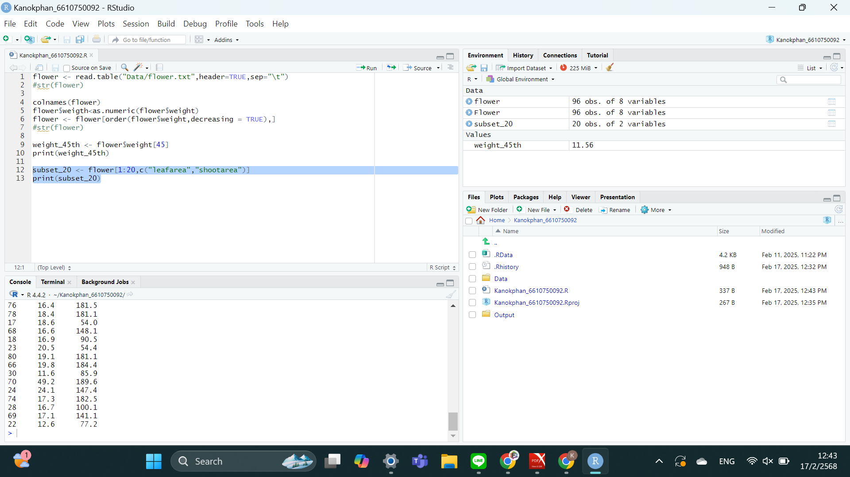
A subset of the dataset containing only the first 20 rows and two variables, leafarea and shootarea, is extracted. This allows for focused analysis on a smaller sample of the dataset, particularly for comparing plant leaf and shoot growth patterns.

Step 5: Compute Summary Statistics Grouped by Nitrogen Levels
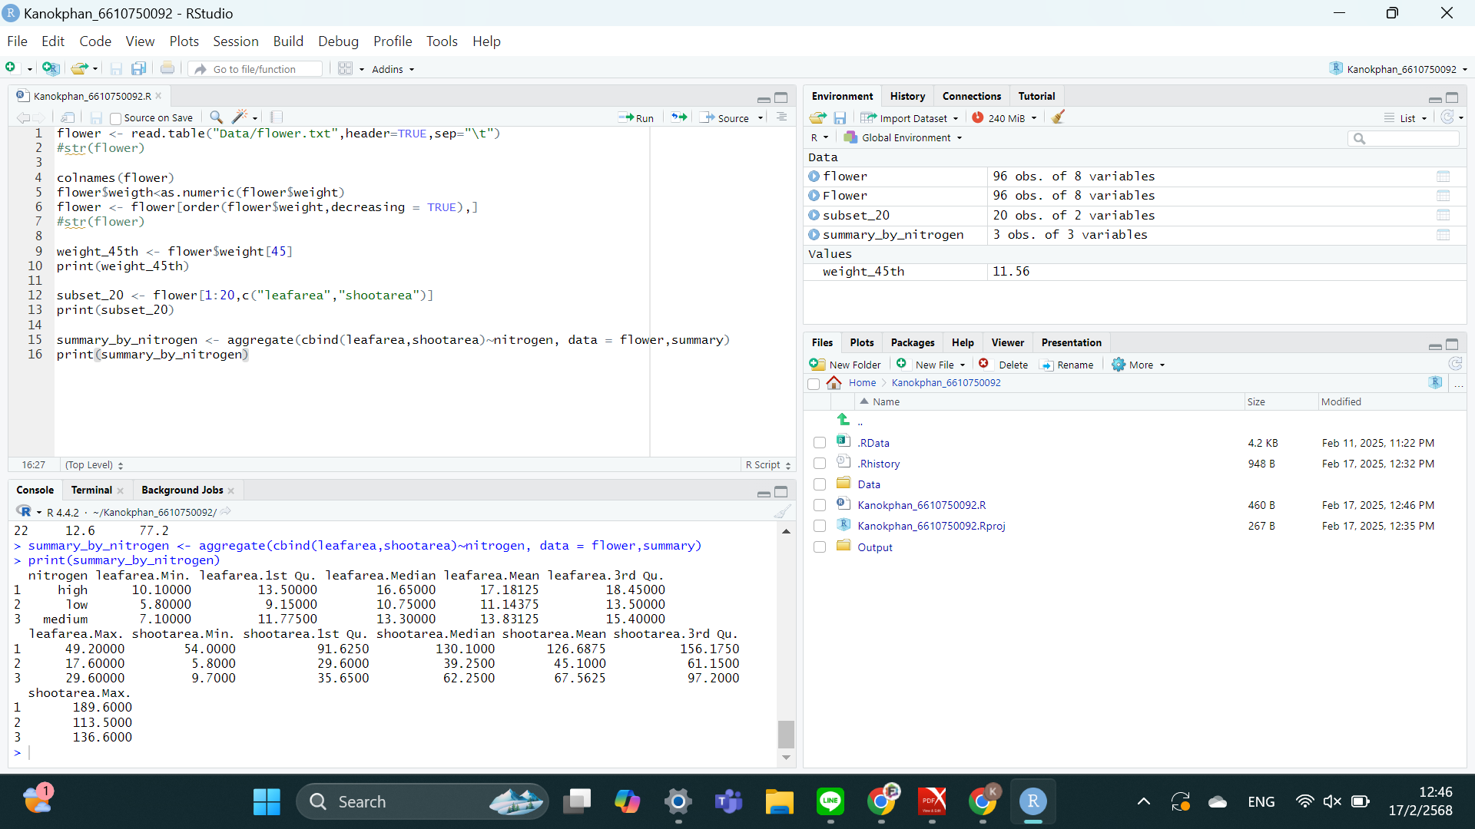
Summary statistics for leafarea and shootarea are calculated for each nitrogen level using the aggregate() function. This groups the data by nitrogen and applies the summary() function to provide key descriptive statistics, helping analyze how nitrogen levels affect plant growth.

Part B:
Step 1: Scatter Plot of Height vs. Shoot Area
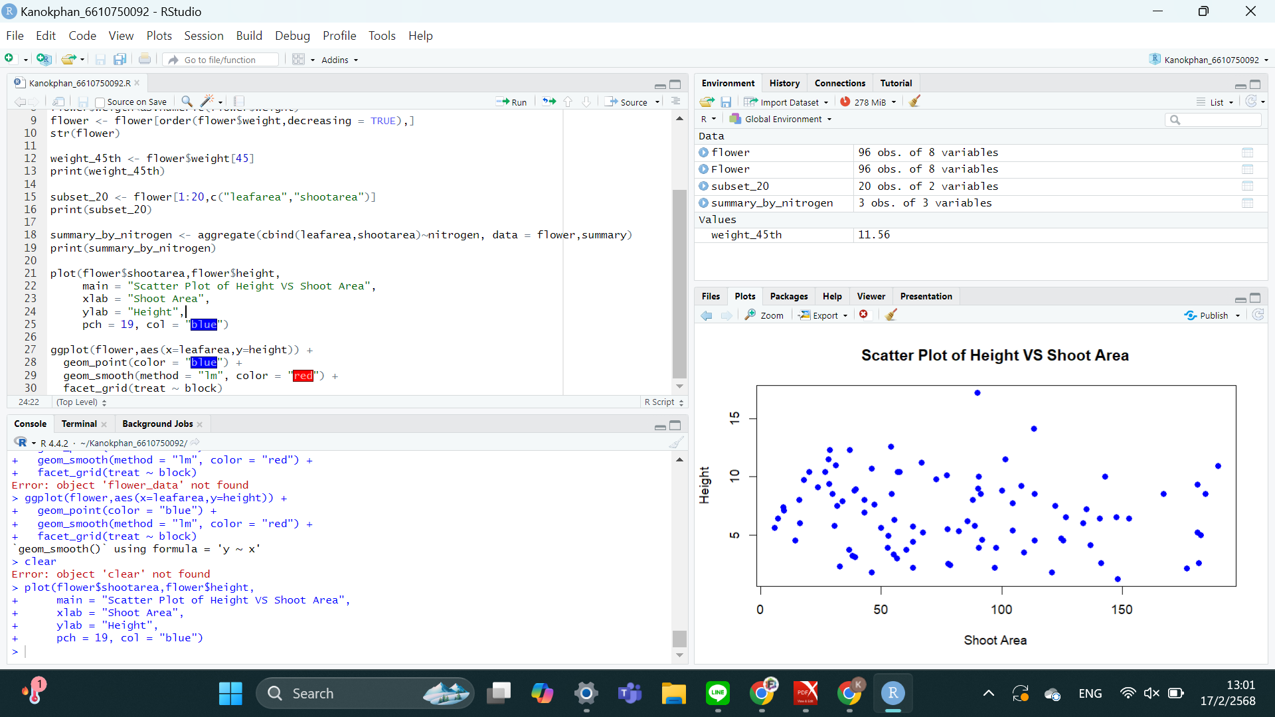
A scatter plot is created using base R plotting functions, where shootarea is on the x-axis and height is on the y-axis. The plot provides a visual representation of the relationship between shoot area and plant height, using blue-colored points for better readability.

Step 2: Scatter Plot of Height vs. Leaf Area with Grouping
Using ggplot2, a more detailed scatter plot is generated with leafarea on the x-axis and height on the y-axis, grouped by nitrogen levels. The facet_grid() function splits the plot by block (rows) and treat (columns), allowing for a comparative view across different conditions. A linear regression trendline is added using geom_smooth(method = "lm") to observe general patterns in the data. The theme_minimal() function ensures a clean and professional presentation.
